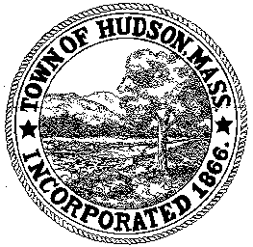

CONSERVATION COMMISSION
78 Main Street, Hudson, MA 01749
(978) 562-2020

Paul Byrne, Chairman W. Minot Wood, Vice Chairman David Esteves, Member

Terrence Joyce, Member Leif Longtine, Member Joseph Rodrigues, Member Al Tashian, Member

Meeting Agenda
April 7, 2011 7:00 P.M.

- Preliminaries
  - Open Meeting
  - Roll Call

2.0 New Business
2.1 DEP 190-0557 continued
Location: 146 Main Street
Applicant: Jose and Maria Peneda
Project Description: Demolition of a portion of the existing structures and the construction of an addition to the building at 146 Main Street, within the floodplain.

2.2 RDA 404
Location: 31 Maple Street
Project Description: Removal of trees within the 100” riverfront area

2.3 Request for Review and Comments: 201 Manning Street

3.0 Old Business
Minutes March 17, 2011

4.0 Correspondence

5.0 Adjournment:

Next Meeting: April 21, 2011

